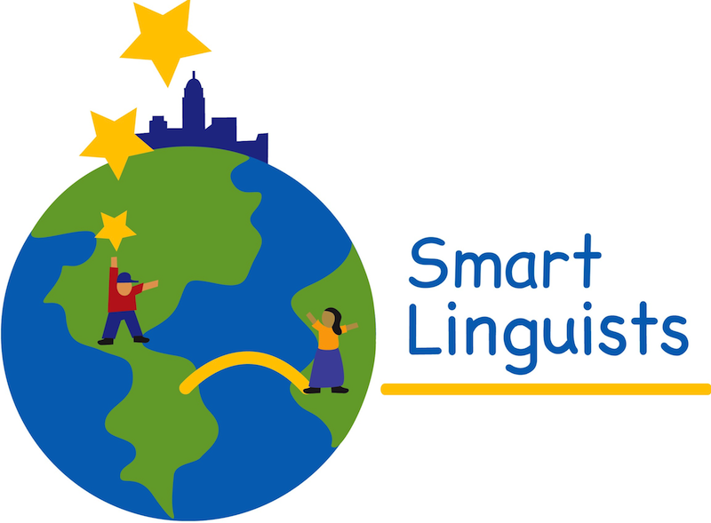

Spanish Online Resources

Recursos para Practicar

Español, en la Red

**EXERCISES TO REVIEW VOCABULARY/ EJERCICIOS PARA PRACTICAR VOCABULARIO**

<http://www.languageguide.org/spanish/vocabulary/>

<http://www.ver-taal.com/vocabulario.htm>

<http://www.digitaldialects.com/Spanish.htm>

http://www.bbc.co.uk/schools/primarylanguages/spanish/

**SPANISH DICTIONARIES / DICCIONARIOS DE ESPAÑOL**

Real Academia Española (Spanish only): <http://dle.rae.es/?w=diccionario>

Word Reference (English/Spanish): <http://www.wordreference.com/>

**VERB CONJUGATION / CONJUGACION DE VERBOS (ADVANCED/AVANZADO)**

[http://www.spanishdict.com/conjugation](http://www.spanishdict.com/conjugation" \t "_blank)

**ACTIVITIES & GAMES / JUEGOS Y ACTIVIDADES**

<http://cvc.cervantes.es/ensenanza/mimundo/default.htm>

<http://www.elhuevodechocolate.com>

<http://www.educa.jcyl.es/zonaalumnos/en/tipologia-recursos/juegos>

[http://pbskids.org/games/spanish/](http://pbskids.org/games/spanish/" \t "_blank)

[http://pbskids.org/noah](http://pbskids.org/noah" \t "_blank)

**iPhone/iPads APPS**

* Kids Spanish - $1.99 - (vocabulary about sports, animals, beach, fruits, shapes, letters, colors, numbers)
* Learn Spanish with Lingo Arcade – Level 1 is free – Levels 3-22 is $0.99 (vocabulary)
* Spanish for Kids with Stories by Gus on the Go – First two stories are free
* Juana la Iguana goes to the farm – Learn Spanish – Free
* Juana la Iguana goes to the Beach – Learn Spanish - $1.99
* Duolingo, Learn Languages for Free – Free
* Poppy Cat Goes to the Market – Free
* Wood Puzzle Easter Colors - $0.99 (colors)